- Go to
- C:\WINDOWS\system32\drivers\etc\
- Select hosts file
- Right click > click open > notepad
- Type :
- 10.235.70.40 TDDEV TDDEVcop1
- 10.235.70.33 TDPROD TDPRODcop1
Or
- Go to Teradata Service Control
- Right click > Click Open
- Go the File Menu > Click on Advenc setup
- Click on edit host
- Type :
- 10.235.70.40 TDDEV TDDEVcop1
- 10.235.70.33 TDPROD TDPRODcop1

For DSN

- Go to the Start > All programs > ODBC > 32Bit ODBC Administor
- Or
- From Teradata Service Contro
- Click on Define DSN
- Go to the system DSN:
- 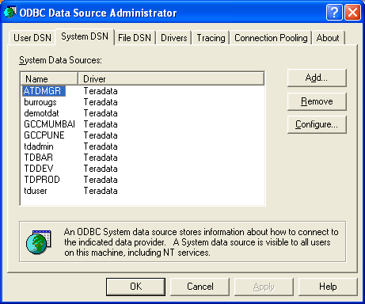

- Click button Add

- 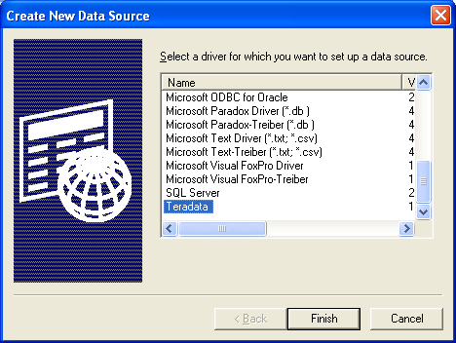

- Click option Teradata then click button Finish

- Type the field same as shown:

- 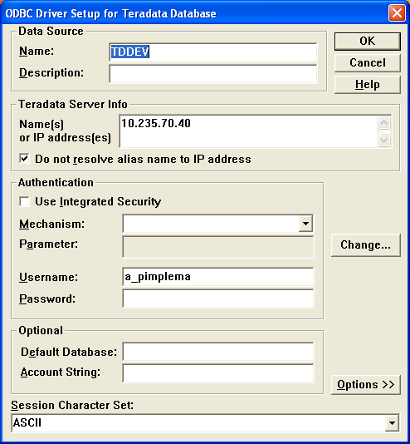

- Just change you username against (a_pimplema)

- Then Click the button OK

- Then come out of by pressing the button OK

- 